ISTE-230 Introduction to Database & Data Modeling

## Practice Exercise # 10 – Transposing II

**Name:** Brian Zarzuela

(It may be helpful to right-click on the  icon and select Hide Spelling Errors and Hide Grammatical Errors.)

**Problem #1**

Using the RITPO diagram that appears below, answer the following questions. **Please account for the note that is at the bottom of the diagram.**

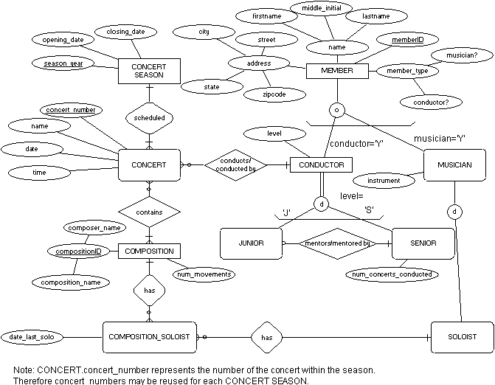

Explain why SOLOIST is weak and what the specific term for that type of entity is.

**REASON:** SOLOIST is weak because an instance can’t exist without an instance of MUSICIAN

**TERM:** subtype entity

Explain why CONCERT is weak and what the specific term for that type of entity is.

**REASON:** can’t exist on it’s own, must participate in the relationships with CONCERT_SEASON, CONDUCTOR, and COMPOSITION

**TERM:** ID-dependant weak entity

**Problem #2**

Transpose the E-R diagram below into relations, implementing all relationships. Denote primary keys and foreign keys appropriately. Use proper relation notation. Make sure your relation names are in all caps. **Please account for the note that is at the bottom of the diagram. Rounded relationship diamonds denote identifying relationships.**



**YOUR TRANSPOSED RELATIONS:**

MEMBER(memberID, firstname, middle_inital, lastname, city, street, state, zipcode, conductor?, musician?)

CONDUCTOR(*memberID*, level)

CONDUCTOR(memberID) mei MEMBER(memberID)

JUNIOR(*memberID*, *mentor_memberID*)

JUNIOR(memberID) mei CONDUCTOR(memberID)

JUNIOR(mentor_memberID) mei SENIOR(memberID)

SENIOR(*memberID*, num_concerts_conducted)

SENIOR(memberID) mei CONDUCTOR(memberID)

MUSICIAN(*memberID*, instrument)

MUSICIAN(memberID) mei MEMBER(memberID)

SOLOIST(*memberID*)

SOLOIST(memberID) mei MUSICIAN(memberID)

CONCERT_SEASON(season_year, operating_date, closing_date)

CONCERT(concert_number, *season_year*, name, date, time, *memberID*)

CONCERT(season_year) mei CONCERT_SEASON(season_year)

CONCERT(memberID) mei CONDUCTOR(memberID)

CONCERT_COMPOSITION(*concert_number, season_year, composition_name, composer_name*)

CONCERT_COMPOSITION(concert_number, season_year) mei CONCERT(concert_number, season_year)

CONCERT_COMPOSITION(composition_name, composer_name) mei COMPOSITION(composition_name, composer_name)

COMPOSITION(composition_name, composer_name, num_movements)

COMPOSITION_SOLOIST(*composition_name, composer_name, memberID*, date_last_solo)

COMPOSITION_SOLOIST(composition_name, composer_name) mei COMPOSITION(composition_name, composer_name)

COMPOSITION_SOLOIST(memberID) mei SOLOIST(memberID)

**Problem #3**

Given the E-R diagram, transposed relations (from PE9 – does not distinguish between identifying and non-identifying relationships) and the functional dependencies shown below, normalize all relations, and any resulting relations through BCNF, using proper relational notation. Note: The lines in the E-R diagram do not distinguish identifying and non-identifying relationships.

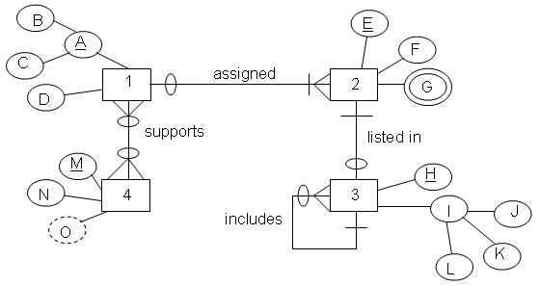

**Functional Dependencies:**

B, C -> D

C->D

D->C

E->F, (B, C)

H-> J, K, L, E, Hb

K-> L

M->N

**The Transposed Relations:**

1(B, C, D)

2(E, F, G, *B, C*)

2(B, C) mei 1(B, C)

3(H, J, K, L, *E, Hb*)

3(E) mei 2(E)

3(Hb) mei 3(H)

4(M, N)

1_4(*B, C, M*)

1_4(B, C) mei 1(B, C)

1_4(M) mei 4(M)

**YOUR FINAL SET OF NORMALIZED RELATIONS:**

1(B, *C*)

1(C) mei 5(C)

2(E, F, *B, C*)

2(B, C) mei 1(B, C)

3(H, J, K, *E, Hb*)

3(E) mei 2(E)

3(Hb) mei 3(H)

3(K) mei 7(K)

4(M, N)

1_4(*B, C, M*)

1_4(B, C) mei 1(B, C)

1_4(M) mei 4(M)

5(C, D)

6(*E, G*)

6(E) mei 2(E)

7(K, L)

**Problem #4**

Transpose the E-R diagram below into relations, implementing all relationships. Denote primary keys and foreign keys appropriately. Use proper relation notation. Make sure your relation names are in all caps.

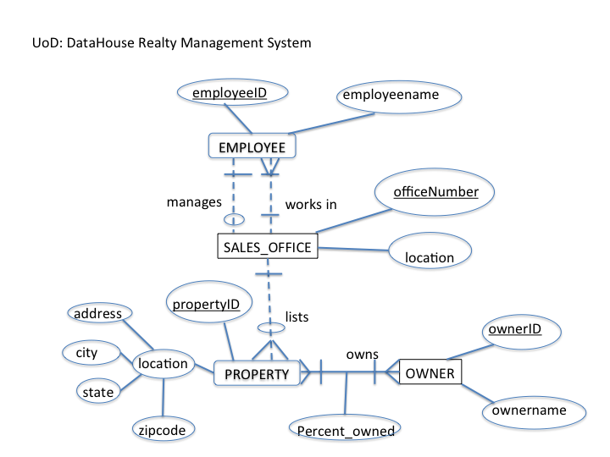

**YOUR TRANSPOSED RELATIONS:**

EMPLOYEE(employeeID, employeename *officeNumber*)

EMPLOYEE(officeNumber) mei SALES_OFFICE(officeNumber)

SALES_OFFICE(officeNumber, location, *manager_employeeID*)

SALES_OFFICE(manager_employeeID) mei EMPLOYEE(employeeID)

PROPERTY(propertyID, address, city, state, zipcode, *officeNumber*)

PROPERTY(officeNumber) mei SALES_OFFICE(officeNumber)

OWNER(ownerID, ownername)

PROPERTY_OWNER(*propertyID, ownerID*, percent_owned)

PROPERTY_OWNER(propertyID) mei PROPERTY(propertyID)

PROPERTY_OWNER(ownerID) mei OWNER(ownerID)

**Problem #5**

Using the DataHouse Realty diagram from Problem #4, please explain what relationship makes PROPERTY weak and what about that relationship causes PROPERTY to be weak.

**YOUR REASON:**

PROPERTY is a weak entity because the lists relationship requires total participation from PROPERTY